
Ngong Deland Ngong - 670411

APT3065
Summer 2026
Project Documentation

ACADEMIC ADVISING APPOINTMENT AND CASE MANAGEMENT SYSTEM (AAACMS)

SYSTEM DESIGN & TECHNICAL REPORT

1. EXECUTIVE SUMMARY & PROBLEM STATEMENT 3
2. SYSTEM OBJECTIVES & SCOPE 3
3. SYSTEM ARCHITECTURE & DESIGN PATTERNS 3
System Workflow Diagram 5
4. DATABASE SCHEMA & DATA DICTIONARY 5
4.1 Model: User (Extended AbstractUser) 6
4.2 Model: AvailabilitySlot 6
4.3 Model: Appointment 6
4.4 Model: CaseLog 6
5. SECURITY & VALIDATION SPECIFICATIONS 7
6. USER ACCEPTANCE TESTING (UAT) & VERIFICATION 7
7. DEPLOYMENT & INSTALLATION GUIDE 8
1. Clone Repository & Navigate: 8
2. Activate Virtual Environment: 8
3. Install Required Dependencies: 8
4. Apply Database Migrations: 8
5. Create Administrative Superuser: 8
6. Launch Local Development Server: 9
7. Access Portal: 9

1. EXECUTIVE SUMMARY & PROBLEM STATEMENT

Traditional academic advising in higher education institutions frequently
faces challenges such as scheduling conflicts, fragmented communication
channels, lack of centralized record-keeping, and communication gaps between
students and faculty advisors.

The Academic Advising Appointment and Case Management System (AAACMS) is a
specialized web application developed to address these operational
inefficiencies. Built with the Python/Django framework and Bootstrap 5, the
platform centralizes appointment scheduling, enforces dynamic slot
availability locking to prevent double-booking, and maintains an auditable
history of advising case notes for each student.

2. SYSTEM OBJECTIVES & SCOPE

The primary objectives of the AAACMS include:

- Role-Based Access Control (RBAC): Differentiate system capabilities across
three user roles: Students, Advisors, and Administrators.
- Real-Time Search & Discovery: Provide students with dynamic multi-field
filtering to find open slots by advisor name or specific dates.
- Concurrency & Double-Booking Protection: Automatically update slot availability
states upon booking to prevent concurrent double-booking.
- Institutional Case Management: Enable advisors to log academic recommendations,
action items, and session notes directly linked to student records.
- User Feedback & UX Polish: Provide immediate visual feedback via Django flash
messages and auto-dismissing Bootstrap alerts.

3. SYSTEM ARCHITECTURE & DESIGN PATTERNS

AAACMS utilizes Django's Model-View-Template (MVT) architectural pattern:

- Models (Data Layer): Encapsulates application data structures, entity
relationships, data constraints, and business logic using Django's ORM.
- Views (Controller Layer): Handles incoming HTTP requests, session state, role-
based routing, form processing, dynamic queryset filtering, and race-condition
validation.
- Templates (Presentation Layer): Dynamic HTML5 templates powered by Django
Template Language (DTL) and styled with Bootstrap 5 for responsiveness.
- Database: Relational SQLite database engine (with migration readiness for
PostgreSQL or MySQL).

System Workflow Diagram
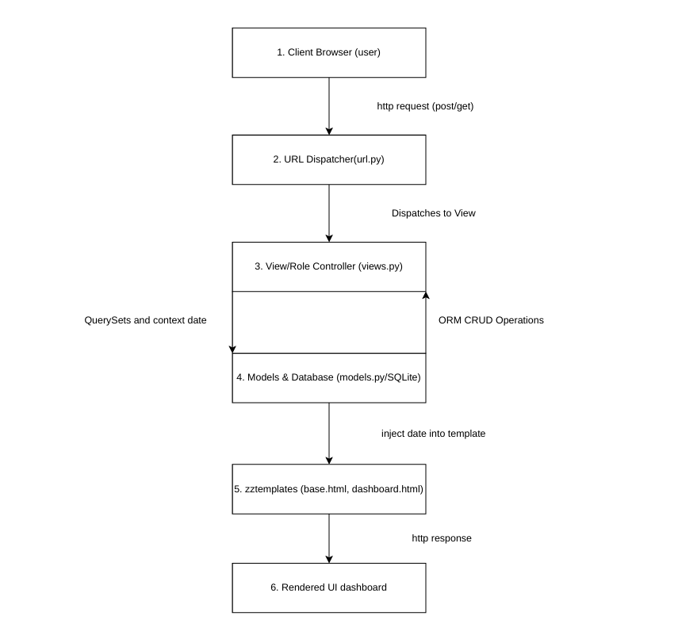

4. DATABASE SCHEMA & DATA DICTIONARY

The database schema consists of four interconnected relational models:

4.1 Model: User (Extended AbstractUser)
- username (CharField, PK/Unique): Primary identity handle for authentication.
- email (EmailField): Primary institutional email address.
- role (CharField): User classification ('student', 'advisor', 'admin').
- department (CharField, Optional): Academic or administrative department.

4.2 Model: AvailabilitySlot
- id (AutoField, PK): Primary key identifier.
- advisor (ForeignKey -> User): The advisor who published the slot.
- date (DateField): Date of the advising slot (YYYY-MM-DD).
- time_slot (CharField): Specific time range (e.g., "10:00 AM - 11:00 AM").
- is_booked (BooleanField, Default=False): State flag indicating if a slot is taken.

4.3 Model: Appointment
- id (AutoField, PK): Primary key identifier.
- student (ForeignKey -> User): Student who booked the session.
- advisor (ForeignKey -> User): Advisor assigned to the session.
- slot (ForeignKey -> AvailabilitySlot, Nullable): Associated slot record.
- date (DateField): Date of the session.
- time_slot (CharField): Scheduled time window.
- issue_category (CharField): Advising topic ('Academic Advising',
'Course Registration', 'Graduation Audit', 'Career Guidance', 'General Inquiry').
- appointment_mode (CharField): Delivery format ('In-Person', 'Virtual').
- meeting_link (URLField, Optional): Virtual meeting URL (e.g., Zoom, Google Meet).
- created_at (DateTimeField): Auto-generated timestamp.

4.4 Model: CaseLog
- id (AutoField, PK): Primary key identifier.
- appointment (ForeignKey -> Appointment): Linked advising appointment.
- advisor (ForeignKey -> User): Advisor authoring the case note.
- student (ForeignKey -> User): Student the session note pertains to.
- notes (TextField): Detailed notes, academic plans, and action items.
- created_at (DateTimeField): Auto-generated logging timestamp.

5. SECURITY & VALIDATION SPECIFICATIONS

- Cryptographic Hashing: User passwords are encrypted using PBKDF2 with SHA-256
and a unique cryptographic salt across all accounts.
- CSRF Protection: Django Cross-Site Request Forgery tokens ({% csrf_token %})
are enforced on all POST forms.
- Route Protection: Endpoints are secured with Django's @login_required decorator
to prevent unauthorized URL access.
- Double-Booking Mitigation: The booking view performs an explicit validation
check on `slot.is_booked` immediately prior to database commit, preventing race
conditions if multiple users attempt booking simultaneously.
- Dynamic Queryset Restriction: Advisor case log forms are scoped dynamically
so advisors can only create logs for appointments assigned to them.

6. USER ACCEPTANCE TESTING (UAT) & VERIFICATION

Test ID | Test Scenario | Expected Outcome | Result
TC-01 | Student/Advisor Login | Routes user to role-based dashboard | PASS
TC-02 | Publish Availability Slot | Slot created with is_booked=False | PASS
TC-03 | Multi-Field Slot Search | Filters slots by Advisor or Date | PASS
TC-04 | Schedule Appointment | Slot state updates to is_booked=True | PASS
TC-05 | Double-Booking Attempt | Displays error flash alert | PASS
TC-06 | Log Case Note | Notes saved and visible to student | PASS
TC-07 | System Logout | Session clears with logout banner | PASS

7. DEPLOYMENT & INSTALLATION GUIDE

To run the AAACMS application locally:

1. Clone Repository & Navigate:
git clone <repository_url>
cd AAACMS_Project

2. Activate Virtual Environment:
# Windows:
env\Scripts\activate
# macOS/Linux:
source env/bin/activate

3. Install Required Dependencies:
pip install -r requirements.txt

4. Apply Database Migrations:
python manage.py makemigrations
python manage.py migrate

5. Create Administrative Superuser:
python manage.py createsuperuser

6. Launch Local Development Server:
python manage.py runserver

7. Access Portal:
- User Dashboard: http://127.0.0.1:8000/
- Django Admin: http://127.0.0.1:8000/admin/

